This guide explains how to convert LabChart files into .txt files automatically. Before beginning, make sure that all LabChart files have been saved to a folder in a location you know (it’s ok if the files are mixed in with TIFF files or something else in the folder, only the LabChart files will be converted).

STEP 1:

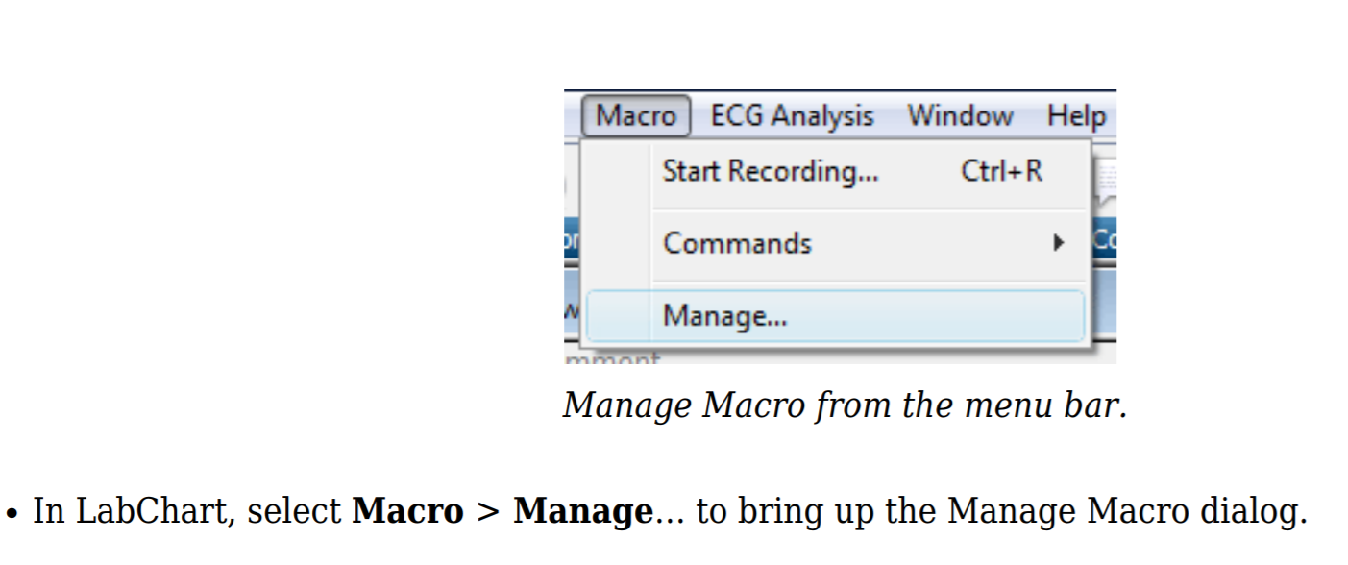

STEP 2:

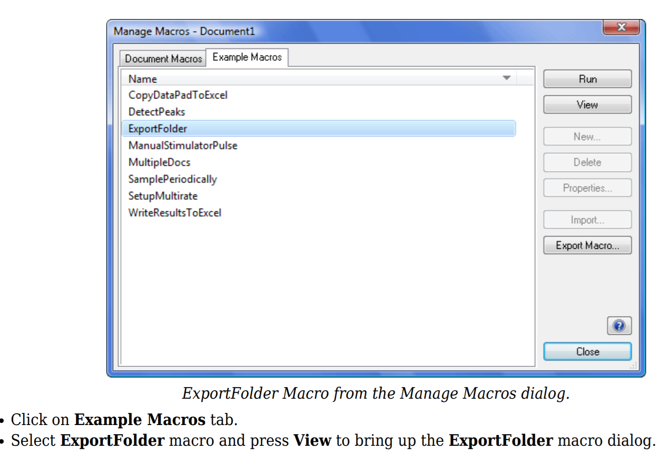

STEP 3:

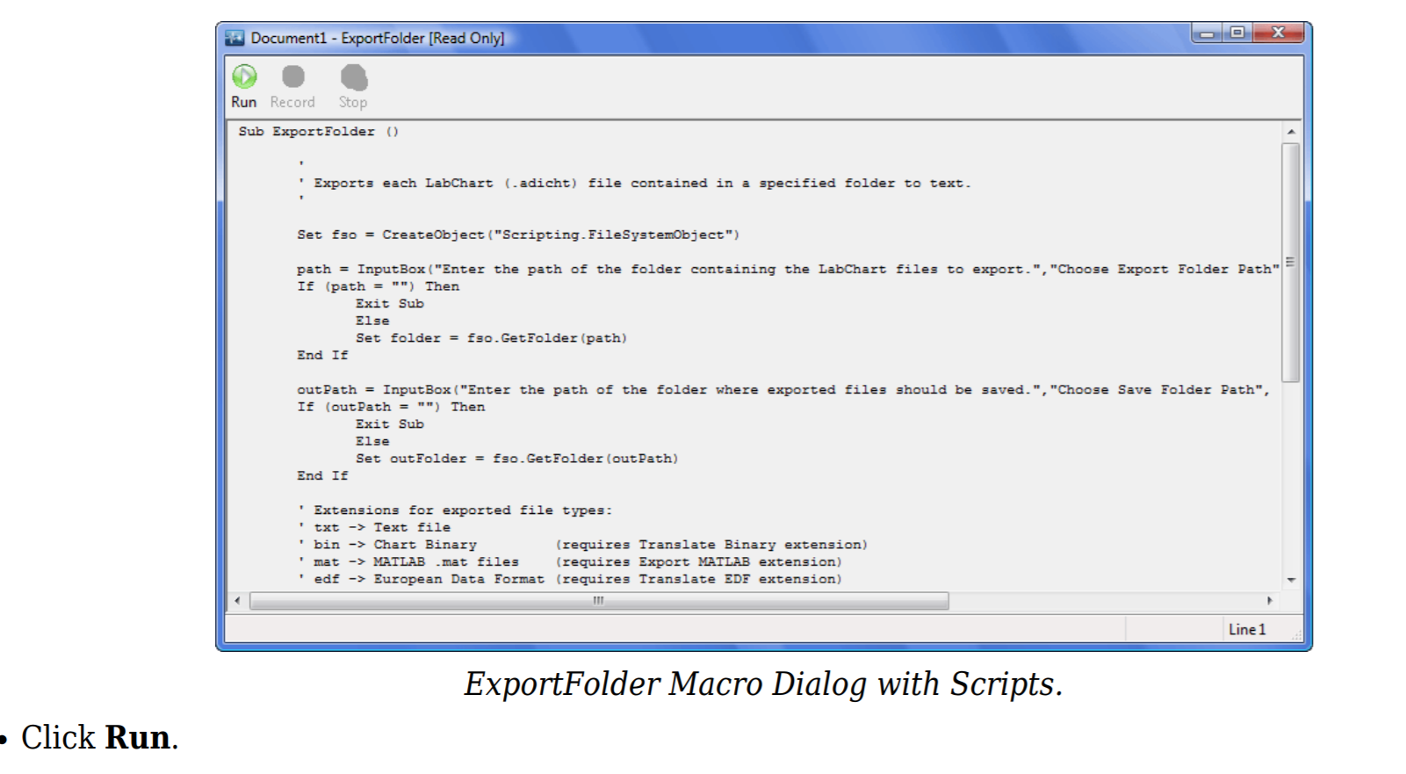

STEP 4:

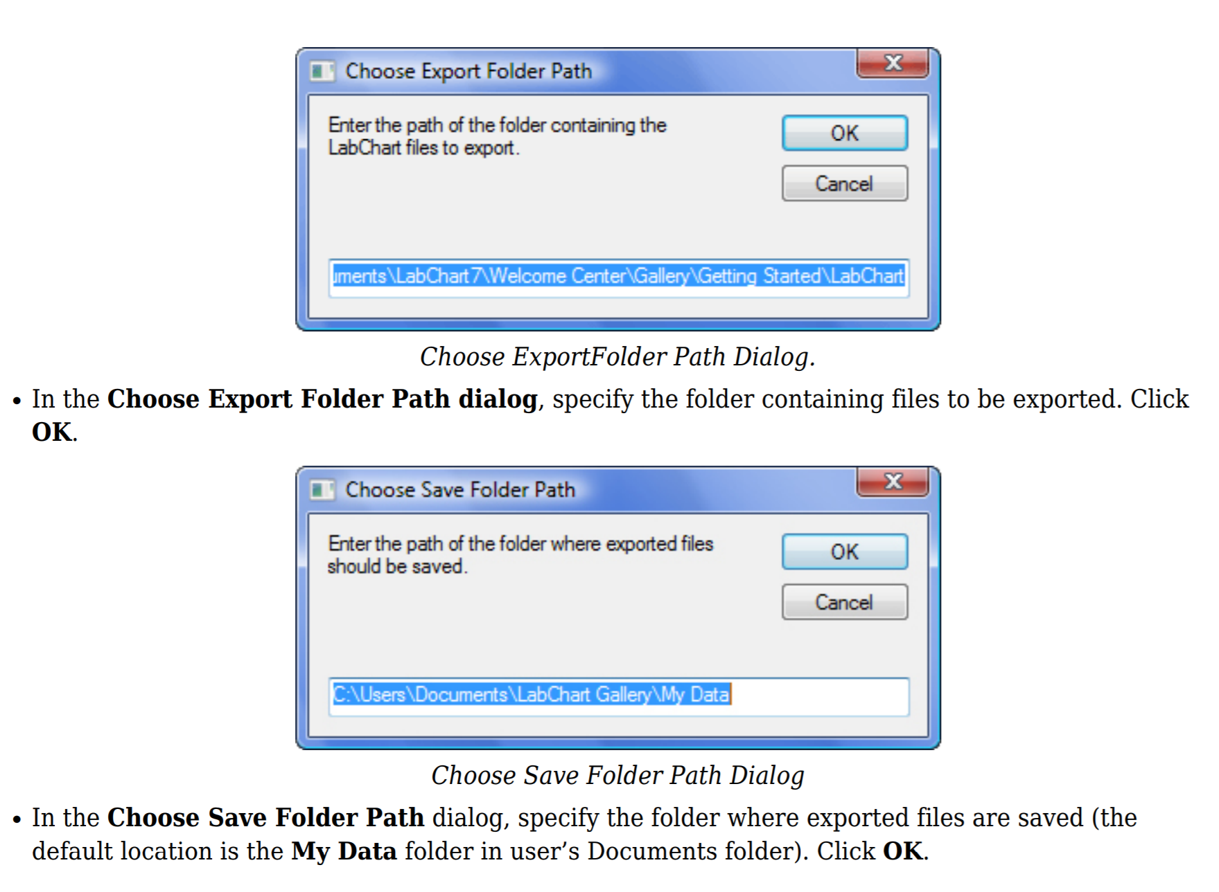

The EXPORT FOLDER is the folder where the original LabChart files are saved, and the SAVE FOLDER is any folder you want to save the .txt files into. It is this SAVE FOLDER that we will use for the next data analysis.